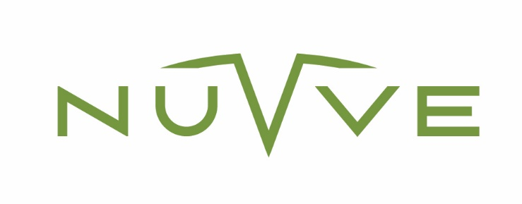
CCPA CONSUMER REQUEST FORM FOR CALIFORNIA RESIDENTS

To enable us to address your consumer request under the CCPA, please complete this form in its entirety and send it to ccpa@nuvve.com.
*Mandatory Fields

I am* (please check only one option):

__ Customer
__ Employee
__ Job Applicant
__ Website Visitor
__ Other: _____________

First Name*: __________________________ Last Name*: __________________________

Email Address*: _____________________________________________________________

Resident of*: ________________________________________________________________

Type of Information Request* (please check only one option):
__ Access My Information
__ Correct or Update My Information
__ Delete My Information
__ Restrict Use of My Information
__ Opt-out or Unsubscribe
__ Transfer My Information
__ Who Has Received My Information

Comments: ____________________________________________________________________________________________________________________________________________________________________________________________________________________________________

Please attach additional information as needed, such as product or service purchased from Nuvve and its subsidiaries.
By submitting this request, I am confirming the following*: (1) Accuracy: the information I have provided is true and accurate; (2) Privacy: that I understand the information will be handled by Nuvve in accordance with its Privacy Policy; (3) Contact: that Nuvve has the right to contact me to verify my identity and to process this request.

Printed Name of Requestor*: _____________________

Signature of Requestor*: ________________________

